5/26/2022

Robert Lothian

HND SOFTWARE DEVELOPMENT

SQL Project

Bobuster Video

Contents

SECTION 1 AND 2 page 2

SECTION 3 page 8

SECTION 4 page 8

SECTION 5 page 10

SECTION 6 page 13

SECTION 7 page 13

Section 1&2

CUST MOVIES ACTORS MEDIA RENTAL HISTORY STAR BILLINGS

*Customer Table*

*Movies Table*

*Actors Table*

*Media Table*

*Rental History*

*Star Billings*

**Section 3**

**Section 4**

**Section 5**

INSERT INTO star_billings

(actor_id, title_id, comments)

VALUES

(1005, 5, 'Blah blah');

Customers

Movies

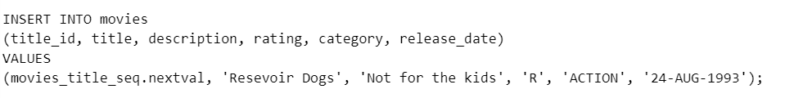

Actors

Media

Rental History

Star Billings

Section 6



Section 7

